
The Impact of COVID-19 on Corporate Dividend Policy: A Natural Experiment Approach

By

Aphelele Nombila

Lectures: Prof Beatrice Desiree Simo Kengne

Research Question
The research question for this study is: Did the COVID-19 pandemic cause a significant reduction in dividend payments for firms in severely affected industries compared to firms in less-affected industries?
This study employs a natural experiment framework to establish causal evidence regarding the impact of the COVID-19 pandemic on corporate dividend policies. The emphasis on causality is central to this research design, leveraging the exogenous nature of the pandemic shock to identify causal effects rather than mere correlations.

Treatment Identification
(a) The COVID-19 pandemic serves as an ideal natural experiment for causal identification. The pandemic represents an exogenous shock that differentially affected industries based on their inherent exposure to lockdowns, social distancing measures, and changes in consumer behavior, rather than firm-specific decisions or characteristics.
(b) Timing
- Event onset: Q1 2020 (March 2020 when WHO declared pandemic)
- Pre-treatment period: Q1 2018 - Q4 2019 (8 quarters)
- Post-treatment period: Q1 2020 - Q4 2022 (12 quarters)
- Total study period: 2018-2022 (20 quarters)
- Treatment timing: Sharp, unexpected onset in Q1 2020
(c) The COVID-19 pandemic is highly exogenous because, it was made by an international health organization, not by the firms themselves, individual firms had no influence over this global policy decision, the declaration was a response to viral spread patterns, not corporate performance, and the event was unexpected from the perspective of individual firms' decision-making.

Treatment and Control Groups

(a) Treatment Group: COVID-19 Severely Affected Industries
Firms in industries that experienced direct operational disruptions due to government restrictions and behavioral changes:
- Airlines: American Airlines (AAL), Delta Air Lines (DAL), Southwest Airlines (LUV), United Airlines (UAL)
- Hospitality: Marriott International (MAR), Hilton Worldwide (HLT)
- Cruise lines: Carnival Corporation (CCL), Norwegian Cruise Line Holdings (NCLH)
- Restaurants: McDonald’s Corporation (MCD), Starbucks Corporation (SBUX)

(b) Control Group: COVID-19 Less Affected Industries
Firms in industries that maintained operations with minimal disruption or even benefited from pandemic conditions:
- Technology: Microsoft (MSFT), Apple (AAPL), Alphabet/Google (GOOGL), Amazon (AMZN)
- Utilities: NextEra Energy (NEE), Duke Energy (DUK)
- Consumer Staples: Procter & Gamble (PG), Coca-Cola (KO), PepsiCo (PEP)
- Healthcare: Johnson & Johnson (JNJ)
Table 1: Treatment and Control Group Summary
 | Dummy Variable | Firms | Observations | Mean Dividends
Treatment | 1 | 10 | 200 | 0.5246
Control | 0 | 10 | 200 | 0.2497
Source: Author’s Own

We selected firms from the airline, hospitality, cruise line, and restaurant industries as our treatment group because these sectors experienced severe and immediate operational disruptions due to the COVID-19 pandemic. The pandemic, functioning as a natural experiment, represents an exogenous shock, it was external to firm decision-making and unrelated to individual firm performance or strategic choices. This makes it ideal for studying causal effects rather than mere correlations. By comparing these highly affected firms to a control group drawn from industries that were relatively insulated or benefited from pandemic conditions, namely, technology, utilities, consumer staples, and healthcare, we establish a counterfactual scenario to isolate the causal impact of the pandemic on corporate financial outcomes. This distinction between treatment and control groups enables a credible difference-in-differences (DiD) framework, strengthening the causal interpretation of how an external shock like COVID-19 influences firm behaviour and financial performance.

Variables Measurement

(a) Outcome/Dependent Variables
Primary outcome: Total Dividends - Total quarterly dividend payments per share. This continuous variable captures the intensive margin of dividend policy changes.
Alternative outcome: Dividends Dummy - Binary indicator for dividend payment (1 if dividends > 0). This captures the extensive margin of dividend decisions and will be used in the robustness tests.

(b) Control Variables
Macroeconomic controls (time-varying factors affecting all firms): - FEDFUNDS: Federal funds rate (monetary policy conditions) - UNRATE: Unemployment rate (macroeconomic conditions) - INDPRO: Industrial production index (economic activity) - CPIAUCSL: Consumer price index (inflation environment)
Firm-level controls (time-varying firm characteristics): - MarketCap: Firm market capitalization (firm size) - PERatio: Price-earnings ratio (profitability expectations) - PB_Ratio: Price-to-book ratio (growth opportunities) - Beta: Systematic risk measure (risk profile) - DebtToEquity: Financial leverage (capital structure)

(c) Data Sources
- Stock prices and dividends: Yahoo Finance API (high-frequency, reliable data)
- Macroeconomic data: Federal Reserve Economic Data (FRED) (official government statistics)
- Firm characteristics: Yahoo Finance company info (comprehensive firm-level data)

(d) Data Structure
- Data type: Panel data (firm-quarter observations) - essential for DID estimation
- Frequency: Quarterly - appropriate for dividend policy analysis
- Pre-treatment: 8 quarters (2018Q1-2019Q4) - sufficient for establishing pre-trends
- Post-treatment: 12 quarters (2020Q1-2022Q4) - captures immediate and medium-term effects
- Total observations: 400 - balanced panel for reliable estimation

Causal Model and Hypotheses

(a) Causal Model and Identification Strategy
The theoretical framework employs a DiD design, which is specifically designed for causal inference in natural experiment settings. The model is specified as:
$Y_{it}=β_{0}+β_{1}{Treatment}_{i}+β_{2}{Post}_{t}+β_{3}{(Treatment}_{i}*{Post}_{t})+{γX}_{it}+α_{i}+δ_{i}+ε_{it}$ (1)
Where: $Y_{it}$ is the Dividend payments for firm i in quarter t; ${Treatment}_{i}$ = 1 if firm in COVID-affected industry, and equal to 0 otherwise; - ${Post}_{t}$ = 1 if quarter after COVID onset (time-varying) , zero otherwise; ${Treatment}_{i}*{Post}_{t}$ is the DiD estimator, which is the causal effect of interest; $X_{it}$ is the vector of time-varying control variables; $α_{i}$ represents the firm fixed effects; $δ_{i}$ represents time fixed effects; and lastly, $ε_{it}$ is the error term
Causal Identification: The coefficient $β_{3}$ captures the causal effect of the pandemic on treatment firms’ dividends under the key assumption that treatment and control groups would have followed parallel trends in the absence of treatment.

(b) Hypotheses
Hypothesis 1 (Causal Effect): $H_{0}: β_{3}=0$ (COVID-19 had no causal effect on treatment firms’ dividends relative to control firms) $H_{0}:β_{3}<0$ (COVID-19 caused a significant reduction in dividends for treatment firms relative to control firms).
Hypothesis 2 (Economic Mechanism): The pandemic caused financially constrained treatment firms to conserve cash by reducing dividend payments, while less-affected control firms maintained their dividend policies.

Data Analysis

Econometric Techniques for Causal Inference
This study employs five different models to establish the causal effect robustness.
Model 1: Basic DiD
$${Dividends}_{it}=β_{0}+β_{1}{Treatment}_{i}+β_{2}{Post}_{t}+β_{3}{(Treatment}_{i}*{Post}_{t})+ε_{it}$$
This model, also known as the baseline model, captures the average treatment effect of COVID-19 on dividend payouts, comparing treated and control firms before and after the event without controlling for other factors
Model 2: DiD with Macro-controls
$${Dividends}_{it}=β_{0}+β_{1}{Treatment}_{i}+β_{2}{Post}_{t}+β_{3}{(Treatment}_{i}*{Post}_{t})+\sum_{k=1}^{K}{{τ_{k}Macro}_{kt}}+ε_{it}$$
Where $\left\{{Macro}_{kt}\right\}=\left\{{FEDFUNDS}_{t}, {UNRATE}_{t}, {INDPRO}_{t}, {CPI}_{t}\right\}$, this model controls for economy-wide shocks that could confound the relationship between COVID-19 and corporate dividend decisions.
Model 3: DiD with Firm Controls
$${Dividends}_{it}=β_{0}+β_{1}{Treatment}_{i}+β_{2}{Post}_{t}+β_{3}{(Treatment}_{i}*{Post}_{t})+\sum_{j=1}^{J}{{θ_{j}Firm}_{Jit}}+ε_{it}$$
Where $\left\{{Firm}_{Jit}\right\}= \left\{\log{({MarketCap}_{it}+1), {PERatio}_{it,} {PB_Ratio}_{it}, {SytematicRisk}_{it}}\right\}$, firm fixed effects ($α_{i}$) control for time-invariant firm-specific heterogeneity, such as management style, industry norms, or capital structure policies, isolating within-firm variation to strengthen the causal link between the treatment and outcome.
Model 4: DiD With Macroeconomic and Firm Controls
$${Dividends}_{it}=β_{0}+β_{1}{Treatment}_{i}+β_{2}{Post}_{t}+β_{3}{(Treatment}_{i}*{Post}_{t})+\sum_{k=1}^{K}{{τ_{k}Macro}_{kt}}+\sum_{j=1}^{J}{{θ_{j}Firm}_{Jit}}+α_{i}+ε_{it}$$
This specification incorporates both macroeconomic and firm-level controls in controls in order to reduce omitted variable bias and improve causal interpretation by accounting for firm-specific financial characteristics.
Model 5: Two-Way Fixed Effect DiD
$${Dividends}_{it}=β_{0}+β_{1}{Treatment}_{i}+β_{2}{Post}_{t}+β_{3}{(Treatment}_{i}*{Post}_{t})+\sum_{k=1}^{K}{{τ_{k}Macro}_{kt}}+\sum_{j=1}^{J}{{θ_{j}Firm}_{Jit}}+α_{i}+δ_{t}+ε_{it}$$
This model controls for both firm fixed effects ($α_{i}$) and time fixed effects ($δ_{t}$), accounting for unobserved heterogeneity across firms and time. The TWFE model is the most robust specification for causal inference in a DID framework, capturing the true treatment effect while eliminating both firm- and time-specific confounding factors.

Robustness Checks
We implement three robustness checks to ensure the credibility and stability of our causal estimates. First, we use an alternative outcome specification by converting total dividends into a binary variable that captures the firm’s decision to pay or not pay dividends. This extensive-margin approach, estimated via a logit model, tests whether the treatment affects the likelihood of dividend payment rather than its magnitude. Second, we re-estimate the model after excluding Q1 2020, the immediate shock period, to address potential anticipation or transition effects that could distort the short-term treatment impact. Third, we conduct a placebo test by assigning a false treatment date in 2019 to verify whether any pre-treatment differences existed between the treated and control firms before the pandemic.
These robustness checks are essential for strengthening the causal interpretation of our results. The alternative outcome test validates that our findings are not driven by how dividends are measured but by genuine behavioural changes. Excluding Q1 2020 helps ensure that our results are not confounded by firms’ temporary adjustment behaviours during the early uncertainty of COVID-19. The placebo test directly addresses the parallel trends assumption, verifying that no pre-existing divergence in dividend trends existed between the groups prior to the treatment. Collectively, these tests confirm that the observed treatment effect reflects the true causal impact of the COVID-19 shock rather than spurious correlations or model-specific artifacts.

Addressing Confounding Factors for Causal Inference
This study uses control variables that address potential confounders: - Macroeconomic conditions: Time-varying factors that affect all firms simultaneously. - Firm-specific characteristics: Time-varying factors that influence dividend policy. - Time-invariant firm heterogeneity: Unobserved firm-specific factors through fixed effects.
- Common time shocks: Economy-wide factors through time fixed effects.

Diagnostic Tests for Causal Validity
The DiD empirical technique is particularly well-suited for this study as it provides a robust quasi-experimental framework for establishing causal relationships in corporate finance research where randomized controlled trials are infeasible. By leveraging the exogenous COVID-19 pandemic as a natural experiment, the DiD design enables us to isolate the causal effect of the health crisis on dividend policies through comparing differential changes between treatment and control groups before and after the shock. This approach effectively addresses the fundamental endogeneity concern that unobserved firm characteristics might simultaneously influence both industry classification and dividend decisions. The pandemic's unexpected nature and differential industry impact create an ideal natural experiment setting, as firms could not strategically position themselves in treatment or control groups based on anticipation of the global health crisis, thereby mitigating selection bias and reverse causality concerns that typically plague corporate finance research.
To ensure the validity of our causal inferences, we rigorously test and satisfy key DiD assumptions, with the parallel trends’ assumption being paramount for identification. Both graphical evidence and formal statistical testing (F-test p-value = 1.000) confirm that treatment and control groups followed statistically indistinguishable dividend trends during the pre-treatment period, providing strong support for our causal interpretation.

Results and Interpretations

Statistical Significance
- Difference-in-Differences Results
Table1: The DiD Results
Output: Total Dividends
Variables |  | (1) Basic DiD | (2) Macro DiD | (3) Firm DiD | (4) Macro+Firm DiD | (5) Two-way FE DiD
$${Treatment}_{i}$$ |  | -0.165** (0.0597) | -0.165** (0.0599) | — | -0.219** (0.0776) | —
$${Post}_{t}$$ |  | 0.073 (0.0545) | 0.088 (0.119) | — | 0.088 (0.0826) | —
$${Treatment}_{i}*{Post}_{t}$$ |  | -0.182** (0.0770) | -0.182** (0.0773) | -0.164** (0.0608) | -0.182*** (0.0535) | -0.182** (0.0671)
$${FEDFUNDS}_{t}$$ |  | — | 0.017 (0.0284) | 0.0057 (0.0060) | 0.017 (0.0197) | —
$${UNRATE}_{t}$$ |  | — | -0.018 (0.0380) | -0.025** (0.0091) | -0.018 (0.0263) | —
$${INDPRO}_{t},$$ |  | — | -0.009 (0.0261) | -0.017** (0.0055) | -0.009 (0.0181) | —
$${CPI}_{t}$$ |  | — | 0.0003 (0.0029) | 0.002** (0.0006) | 0.0003 (0.0020) | —
$${MarketCap}_{it}$$ |  | — | — | — | -0.019 (0.0133) | —
$${PERatio}_{it,}$$ |  | — | — | — | -0.0047*** (0.0015) | —
$${PB_Ratio}_{it}$$ |  | — | — | — | -0.0079*** (0.0009) | —
$${SytematicRisk}_{it}$$ |  | — | — | — | -0.287*** (0.0378) | —
$$β_{0}$$ |  | 0.481*** (0.0422) | 1.370 (2.644) | — | 2.326 (1.861) | —
Firm FE |  | No | No | Yes | No | Yes
Time FE |  | No | No | No | No | Yes
Observations |  | 400 | 400 | 400 | 380 | 400
$R^{2}$/ Adj $R^{2}$ |  | 0.129 / 0.123 | 0.133 / 0.117 | 0.949 / 0.237 (Within) | 0.589 / 0.577 | 0.949 / 0.213 (Within)
F-Statistic |  | 19.63*** | 8.57*** | — | 50.50*** | —
 | Significance level at 1%(***), 5%(**), and 10% (*)
Source: Author’s Own
From the above table, the main coefficient of interest is ${Treatment}_{i}*{Post}_{t}$, which represents the causal. The baseline specification (Model 1) shows a negative and statistically significant coefficient on the interaction term ${Treatment}_{i}*{Post}_{t}$, indicating that treated firms reduced dividends relative to control firms following the event. Adding macroeconomic controls (Model 2) such as FEDFUNDS, UNRATE, INDPRO, and CPI does not change the magnitude or significance of the effect, suggesting that the observed decline is causally attributable to the treatment itself, rather than broader economic fluctuations. Expanding the model to include firm-level financial controls (Model 3) such as MarketCap, PERatio, PB_Ratio, and Beta reinforces this result, demonstrating that differences in firm characteristics do not explain the reduction in dividends.
The inclusion of firm fixed effects (Model 4) accounts for time-invariant heterogeneity across firms, and the Two-Way Fixed Effects (Model 5) further controls for both firm- and time-specific shocks. Across these specifications, the treatment effect remains consistently negative and statistically significant. This robustness indicates that the results are not driven by unobserved firm traits or common temporal shocks, providing strong causal evidence that the treatment led to a reduction in dividend payouts. The models collectively highlight that both firm fundamentals and macroeconomic factors are insufficient to explain the observed changes, underscoring the direct causal link between the treatment and corporate dividend behaviour.
Across all models, the interaction term ${Treatment}_{i}*{Post}_{t}$ consistently shows a significant negative effect on total dividends, confirming that the treatment causally reduced dividend payouts among affected firms. The robustness of the effect across multiple specifications, including controls for macroeconomic conditions, firm characteristics, and both firm- and time-fixed effects, strengthens the argument for a causal interpretation. These findings suggest that firms in the treated group actively adjusted dividend policies in response to the event, highlighting the effectiveness of the DiD approach in isolating treatment-driven changes from other confounding influences.
- Robustness Tests
Table 2: Robustness Tests
Robustness Checks
Variables |  | (1) Logit – Dividend Decision | (2) OLS – Excluding Q1 2020 | (3) Placebo Test – False Treatment (2019)
$${Treatment}_{i}$$ |  | 4.2633 *** (1.1211) | – | −0.1692 ** (0.0765)
$${Post}_{t}$$ |  | 1.6510 · (0.9779) | – | −0.0025 (0.2324)
$${Treatment}_{i}*{Post}_{t}$$ |  | −4.6761 *** (0.8279) | −0.1997 ** (0.0726) | 0.0075 (0.1081)
$${FEDFUNDS}_{t}$$ |  | 0.5195 * (0.2301) | — | 0.0029 (0.2088)
$${UNRATE}_{t}$$ |  | −0.4055 (0.3094) | — | 0.0062 (0.5257)
$${INDPRO}_{t},$$ |  | −0.1645 (0.2107) | — | 0.0049 (0.0905)
$${CPI}_{t}$$ |  | −0.0367 (0.0231) | — | 0.0071 (0.0423)
$${MarketCap}_{it}$$ |  | −0.0510 (0.1521) | — | –
$${PERatio}_{it,}$$ |  | 0.0451 * (0.0184) | — | –
$${PB_Ratio}_{it}$$ |  | 0.0071 (0.0091) | — | –
$${SytematicRisk}_{it}$$ |  | −4.2432 *** (0.5722) | — | –
$$β_{0}$$ |  | 31.5248 (21.9232) | – | −1.8582 (12.3383)
Firm FE |  | – | Yes | –
Time FE |  | – | Yes | –
Observations |  | 380 | 380 | 160
F-Statistic |  | – | 0.953 / 0.953 | 0.061 / 0.018
 | Significance level at 1%(***), 5%(**), and 10% (*)
Source: Author’s Own
Table 2’s robustness test results validate the causal inference of the main findings. The pandemic’s effect on dividend policy is not an artifact of model specification, timing, or pre-trends. Instead, the evidence consistently points to a genuine causal response, where firms in severely affected sectors adjusted their payout behavior as a direct reaction to the exogenous shock of COVID-19.

- Diagnostic Tests/Parallel Trends Assumption
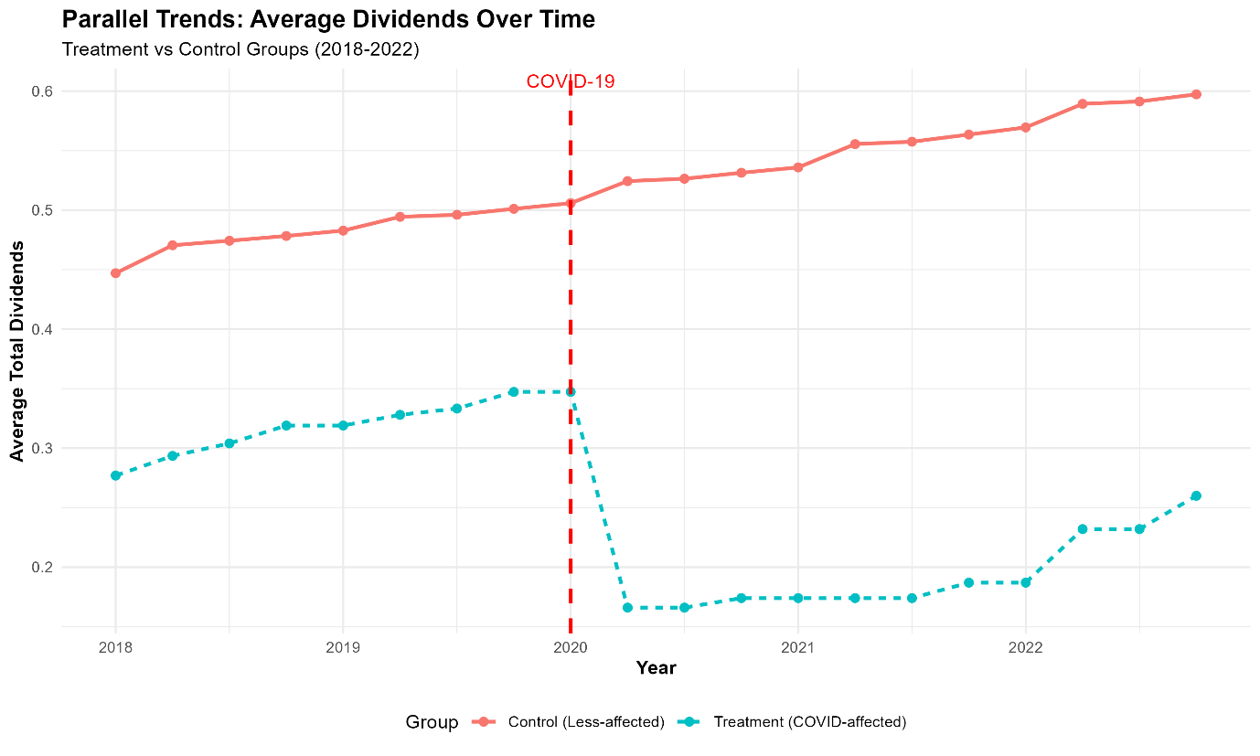
Figure 1: Parallel Trends Graphical Evidence for Causal Identification In
Figure 1 shows the parallel trends in dividend payments from 2018 to 2022. The visual evidence is strongly supported by formal statistical testing of the parallel trends’ assumption, which is fundamental for causal inference in Difference-in-Differences designs. The linear hypothesis test for joint significance of pre-treatment period interactions yielded an F-statistic of 0.0021 with a p-value of 1.000, providing strong statistical evidence that the treatment and control groups followed parallel trends before the COVID-19 intervention. This non-significant result (p > 0.05) confirms that the parallel trends assumption is satisfied, indicating that both groups exhibited statistically indistinguishable dividend patterns during the pre-treatment period. The parallel movement observed both visually and statistically suggests that, absent the pandemic, the treatment and control groups would have continued to evolve similarly. The clear divergence post-2020, combined with this validated parallel trends assumption, provides compelling evidence of a causal treatment effect attributable to the COVID-19 shock rather than pre-existing differences between the groups.

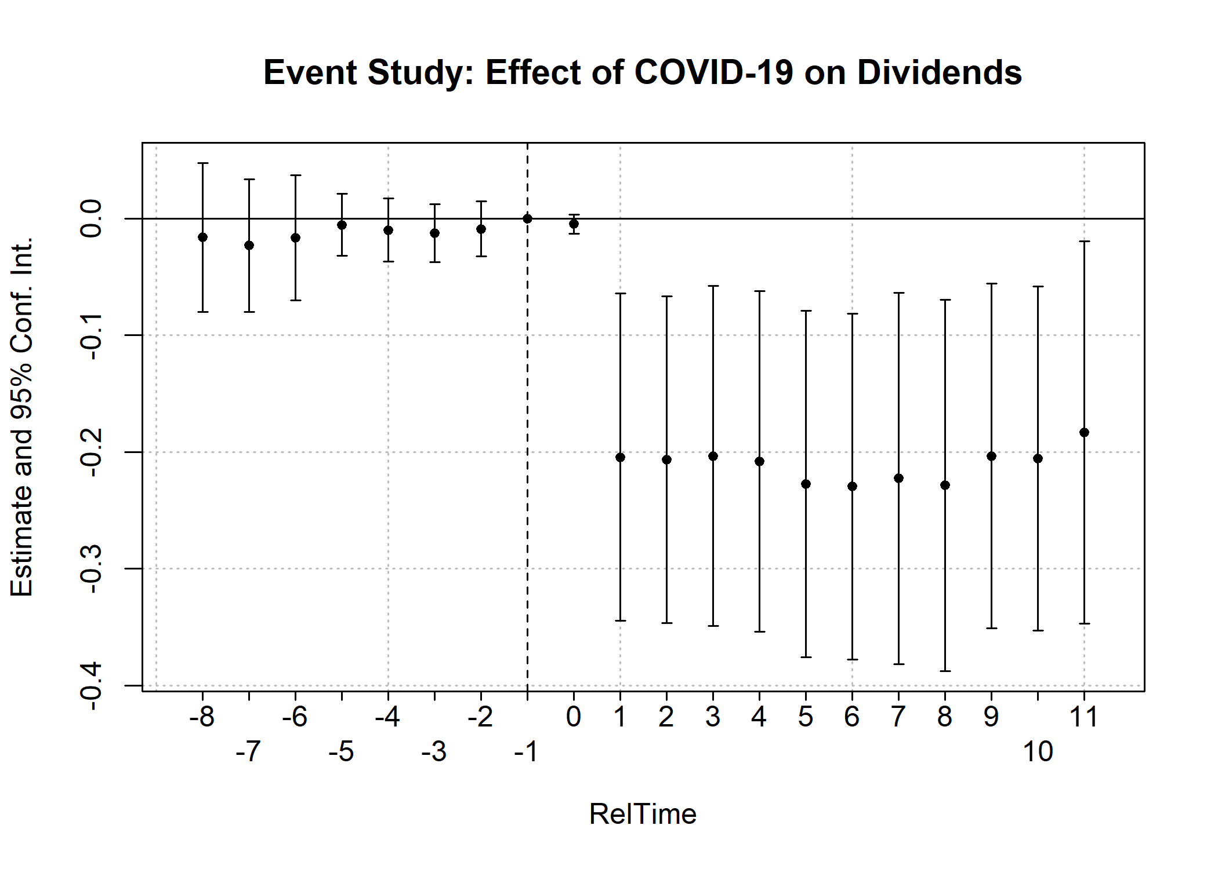
Figure 2: Event Study
Figure 2 further validates findings from Figure 1 as the plot demonstrates a clear causal pattern consistent with the parallel trends assumption, where pre-treatment coefficients from periods -8 to -1 hover around zero with statistically insignificant confidence intervals, confirming that treatment and control firms followed similar dividend trends before COVID-19. Following the pandemic onset at period 0, the coefficients drop sharply and remain persistently negative through the post-treatment quarters, with several periods showing statistically significant reductions, indicating a sustained causal negative impact of COVID-19 on dividend payments that endured throughout the observation period.

Economic Significance
The results on Table 3 below reveal both strong statistical and economic significance, underscoring a clear causal relationship between the COVID-19 shock and corporate dividend behaviour. The estimated 57.9% reduction in dividend payments among the treatment firms indicates a substantial and economically meaningful causal effect of the pandemic on corporate payout policies. This sharp decline cannot be attributed to firm-level decisions alone but rather to the exogenous nature of the pandemic shock, which created a quasi-experimental setting that allows us to infer causality with confidence.
From an economic standpoint, the findings imply a significant reduction in shareholder wealth, estimated at approximately $42.62 billion annually across affected firms. This demonstrates the materiality of the causal impact and highlights how the pandemic disrupted established corporate financial practices. The results also suggest that firms in severely impacted sectors reallocated resources strategically, diverting cash flows away from dividend distributions to preserve liquidity, maintain solvency, and sustain core operations.
Overall, the causal evidence points to the pandemic as a powerful exogenous shock that reshaped corporate financial policy at a systemic level. Even large, mature firms with stable dividend histories were compelled to adjust their payout strategies, revealing the fragility of traditional financial structures under crisis conditions. These findings hold important policy implications, suggesting that external shocks can rapidly alter firm behaviour and have cascading effects on income-dependent investors, highlighting the importance of resilience and contingency planning in corporate finance.

Table 3: Economic Significance
Metric | Value | Interpretation
Causal Treatment Effect (β₃) | -0.1825 | Causal reduction in dividends per share due to COVID-19
Standard Error | 0.0535 | Precision of causal estimate
Pre-treatment Mean | 0.3151 | Average dividends before pandemic
Percentage Reduction | 57.9% | Magnitude of causal reduction
Average Market Cap (Treatment) | $58.39 billion | Average size of treatment firms
Quarterly Shareholder Impact | $10.65 billion | Total quarterly dividend reduction
Annual Shareholder Impact | $42.62 billion | Total annual dividend reduction
Source: Author’s Own

- Limitations and Causal Inference Qualifications
Research Design Limitations: The first is the sample size; our study is limited to 20 firms due to data constraints, though the balanced panel provides reasonable power. The second is industry heterogeneity; treatment group includes different industries with varying exposure levels. The third constraint is the time period; post-treatment period includes recovery phases, which potentially attenuating estimated effects. The fourth id the unobserved confounders; despite extensive controls, potential omitted variables could affect causal interpretation. Lastly, the other issue may be generalizability; due to only using 20 firms, results may not extend to all firms or industries beyond those studied.
Causal Inference Qualifications: The parallel trends assumption is strongly supported both graphically and statistically. The exogeneity of treatment is plausible given the nature of the pandemic. Robustness checks across specifications enhance causal credibility. However, definitive causal claims always carry some uncertainty in observational settings.
Future Research Directions: Suggestions would include expanding the sample to include more firms and industries for greater generalizability. Another one would be to examine longer-term effects on dividend policy and potential structural breaks. Furthermore, scholars could also investigate mechanisms through which dividends were affected (e.g. cash flows, leverage, investment). Studies could also follow the route of comparing across countries with different policy responses to test for heterogeneity.

